Python Log Analyzer Utility Runbook
Project Name: Log Analyzer Utility
Author: Deepak Kumar Jha
Technology: Python 3.13, Git, GitHub
Objective: Develop a reusable Python utility to automate log analysis and reporting.

1. Project Overview
Purpose
The Log Analyzer Utility is designed to analyze application log files and generate operational insights.
The utility helps support and operations teams by:
- Identifying log message counts
- Detecting application errors
- Generating summary reports
- Automating repetitive log analysis activities

2. Project Evolution
Version 1 – Basic Log Analyzer
File - log_analyzer.py
Features
- Reads log file
- Counts INFO messages
- Counts WARNING messages
- Counts ERROR messages
Screenshot
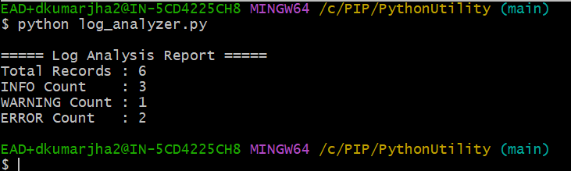

Version 2 – Enhanced Error Analysis
File - log_analyzer_upgraded.py
Features
- Extracts error messages
- Displays detailed error information
- Improves troubleshooting visibility
Screenshot
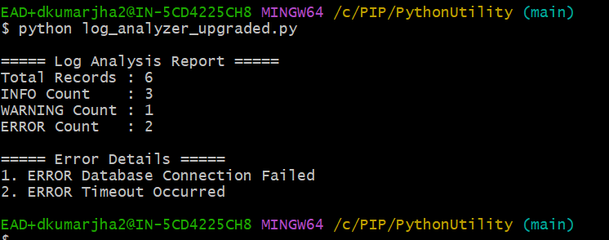

Version 3 – CSV Report Generation
File - log_analyzer_v3.py
Features
- Generates CSV report
- Produces structured output
- Supports reporting requirements
Generated File
log_report.csv
Screenshot
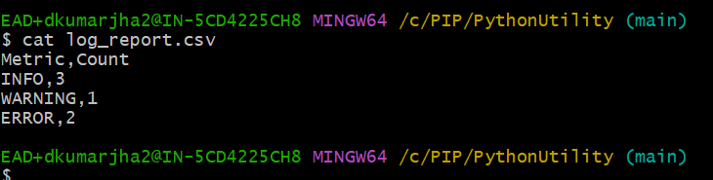
Version 4 – User Input Support
File - log_analyzer_v4.py
Features
- Accepts log file name from user
- Removes hardcoded file dependency
- Supports multiple log files
Sample Execution
python log_analyzer_v4.py
Sample Input
application.log
Screenshot
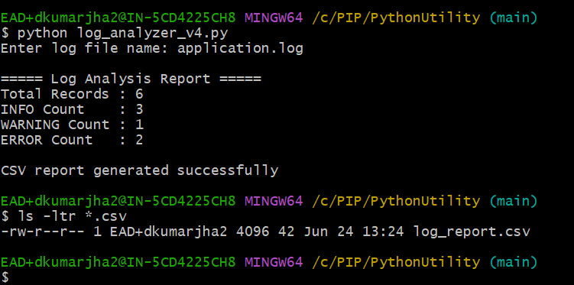

Version 5 – Refactored Utility with Unit Testing Support
File - log_analyzer_v5.py
Features
- Refactored into reusable function
- Improved maintainability
- Supports automated testing
- Follows modular design principles

Function
analyze_log("application.log")
Return Value
(3, 1, 2)
Where:
- INFO Count = 3
- WARNING Count = 1
- ERROR Count = 2
Screenshot
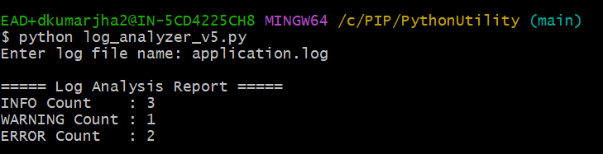

3. Unit Testing
Test File - test_log_analyzer.py
Purpose
Validates that the application produces expected results.
Test Cases
assert info == 3
assert warning == 1
assert error == 2
Expected Output
All tests passed successfully
Screenshot
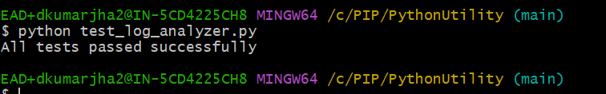

4. Repository Structure
PythonUtility/
│
├── application.log
├── log_analyzer.py
├── log_analyzer_upgraded.py
├── log_analyzer_v3.py
├── log_analyzer_v4.py
├── log_analyzer_v5.py
├── test_log_analyzer.py
├── log_report.csv
└── README.md
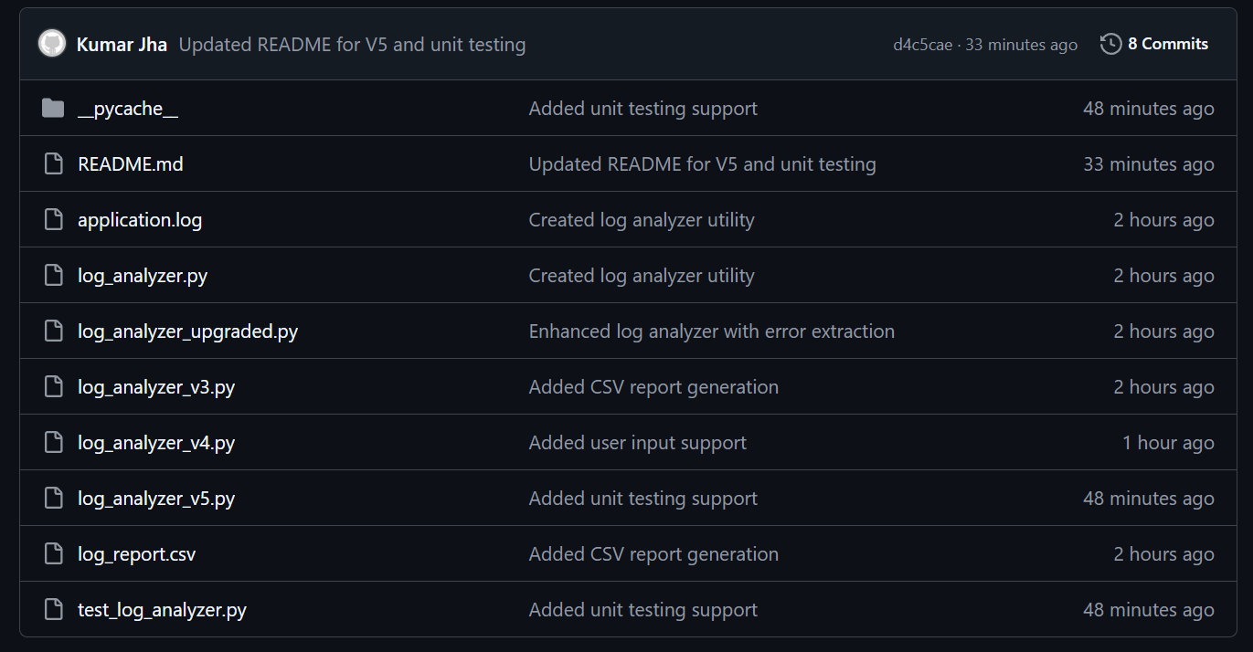

5. Git Commands Used
Initialize Repository : git init
Add Files : git add .
Commit Changes : git commit -m "Commit Message"
Push to GitHub : git push

6. Business Benefits
- Reduces manual log analysis effort
- Provides quick visibility into application health
- Supports operational monitoring activities
- Generates reusable reports
- Demonstrates automation capability

7. Learning Outcomes
The following technical skills were developed during this project:
- Python Programming
- File Handling
- Conditional Statements
- Functions
- CSV Report Generation
- User Input Handling
- Unit Testing
- Git Version Control
- GitHub Repository Management
- Technical Documentation

8. Troubleshooting Guide
Issue | Resolution
File not found | Verify log file exists
Incorrect counts | Verify log file content
Python command not working | Check Python installation
CSV not generated | Verify file write permissions
Unit test failure | Verify expected values in test script

10. Conclusion
The Log Analyzer Utility was successfully developed as a reusable Python-based automation solution. The project evolved through five versions, introducing enhanced functionality such as error extraction, CSV report generation, user input support, modular design, and unit testing. Source code is maintained in GitHub with complete documentation and version history.

